**Experiment 8–Migrate to Amazon RDS**

**AIM:**To migrate from MySQL to Amazon RDS with AWS DMS.

**PROCEDURE:**

1. Firstly, open the AWS console homepage on browser (<https://aws.amazon.com/console/> ).

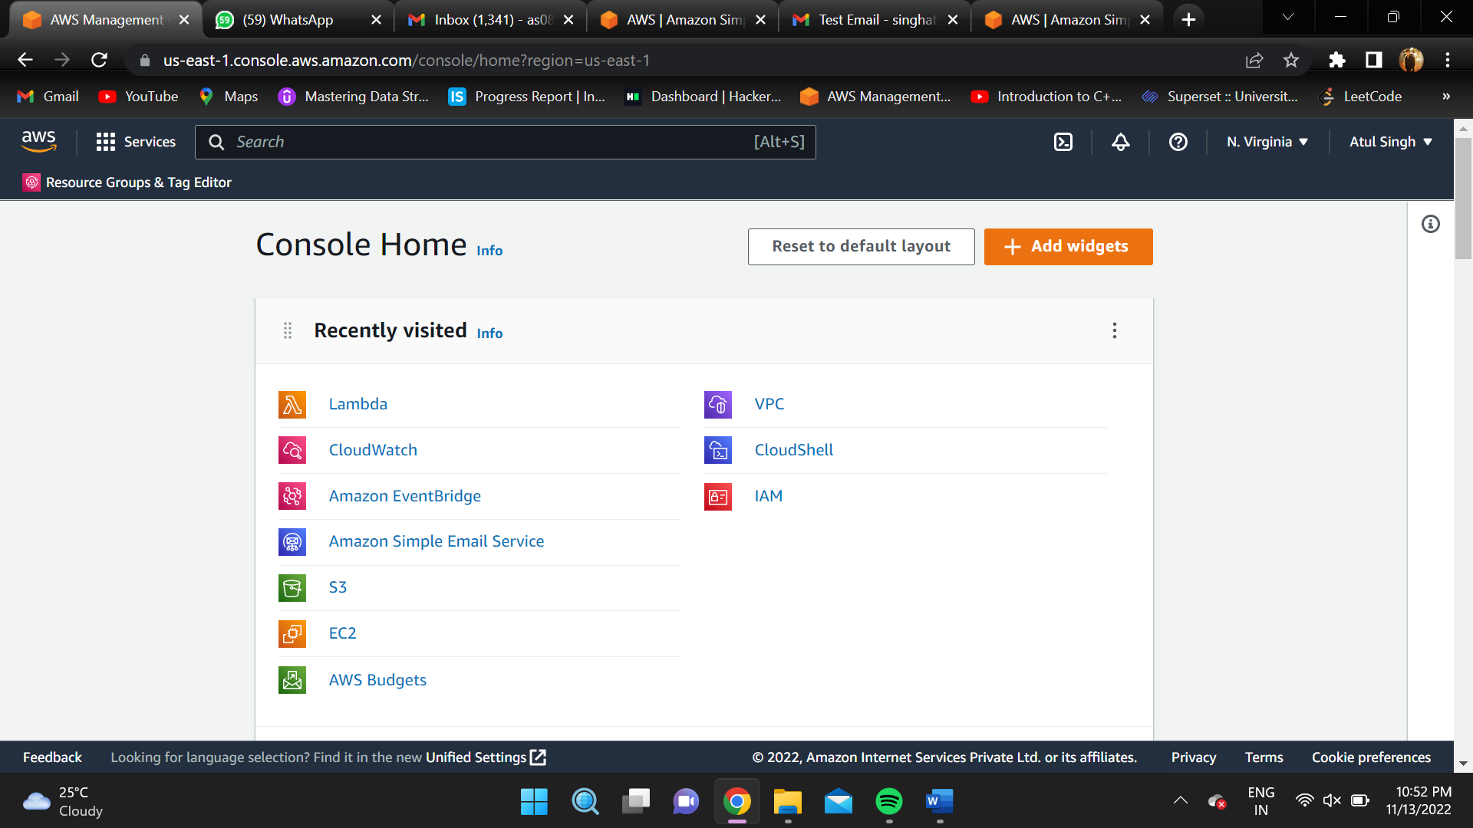

1. Go to Amazon RDS console and select “Create database”.

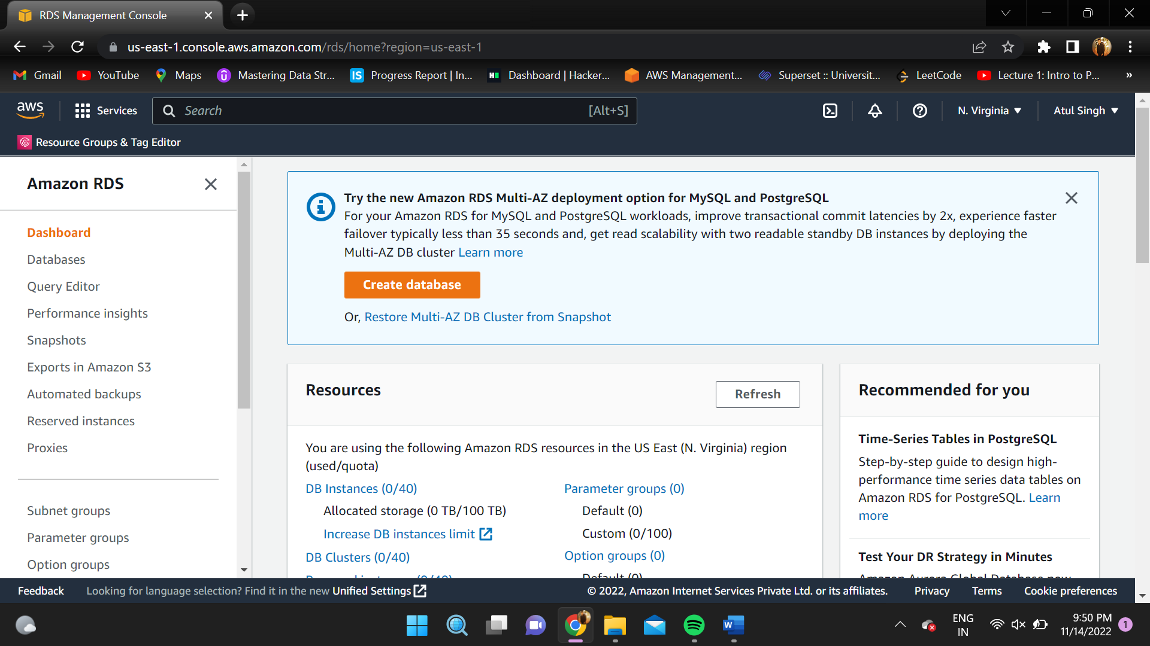

1. Select MySQL engine as engine type in the “Create database page”.

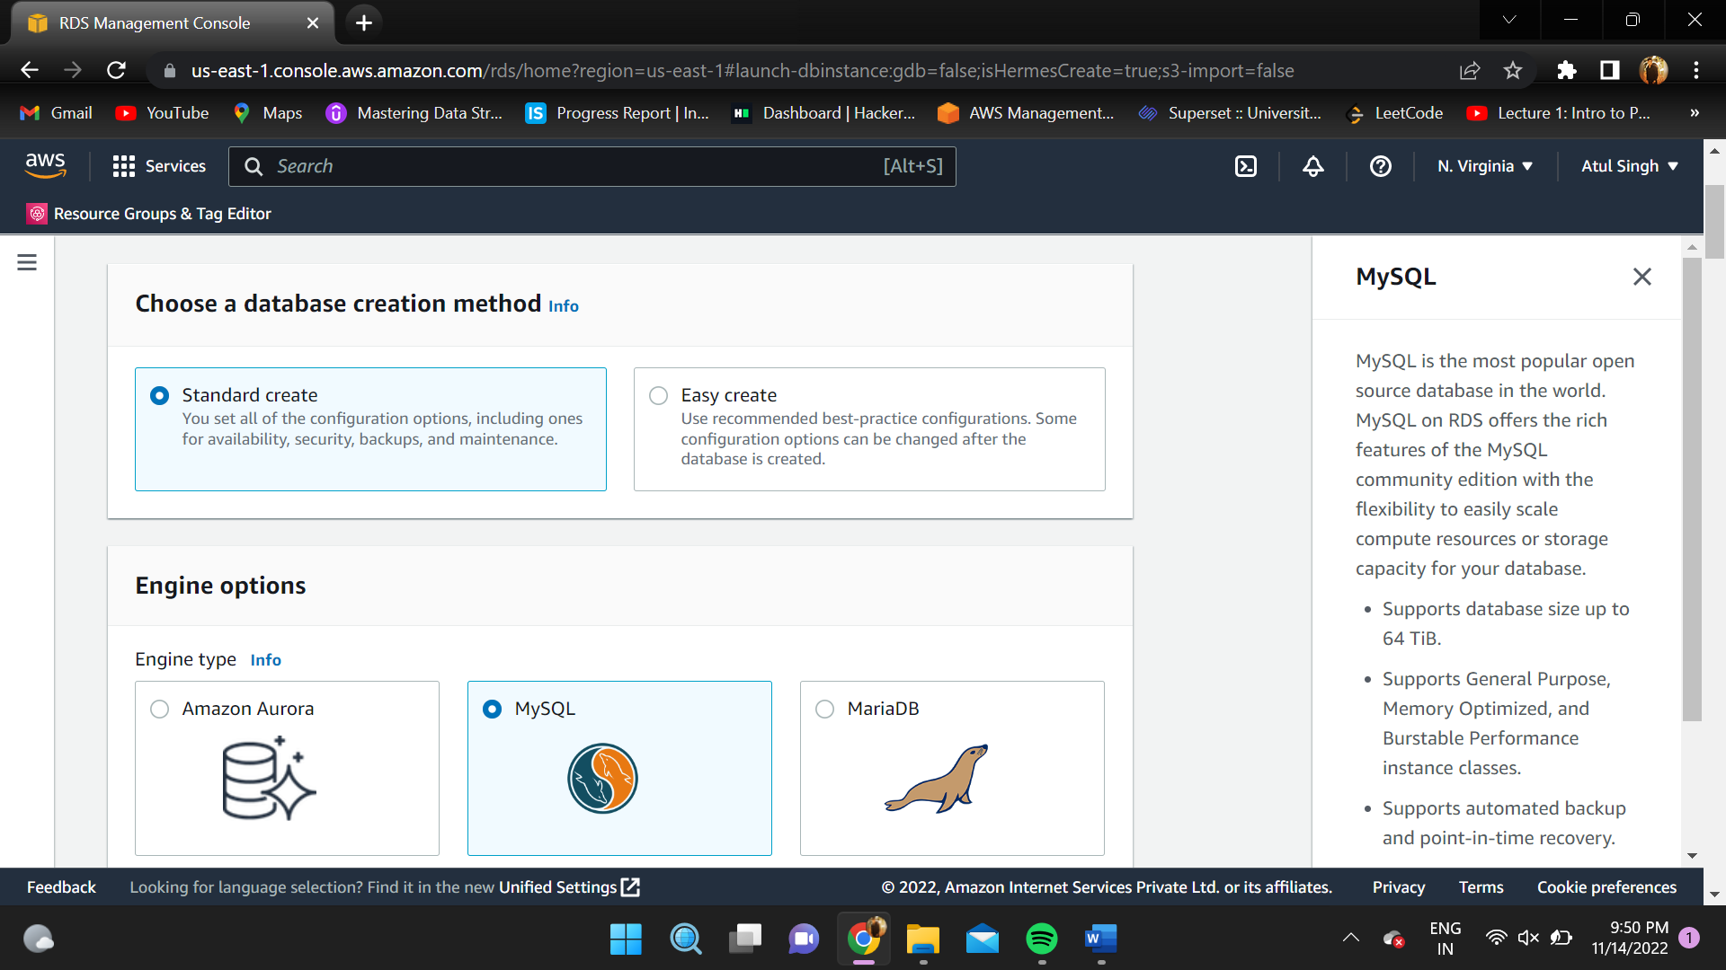

1. Click on “Free Tier” as templates and leave other configurations as it is.

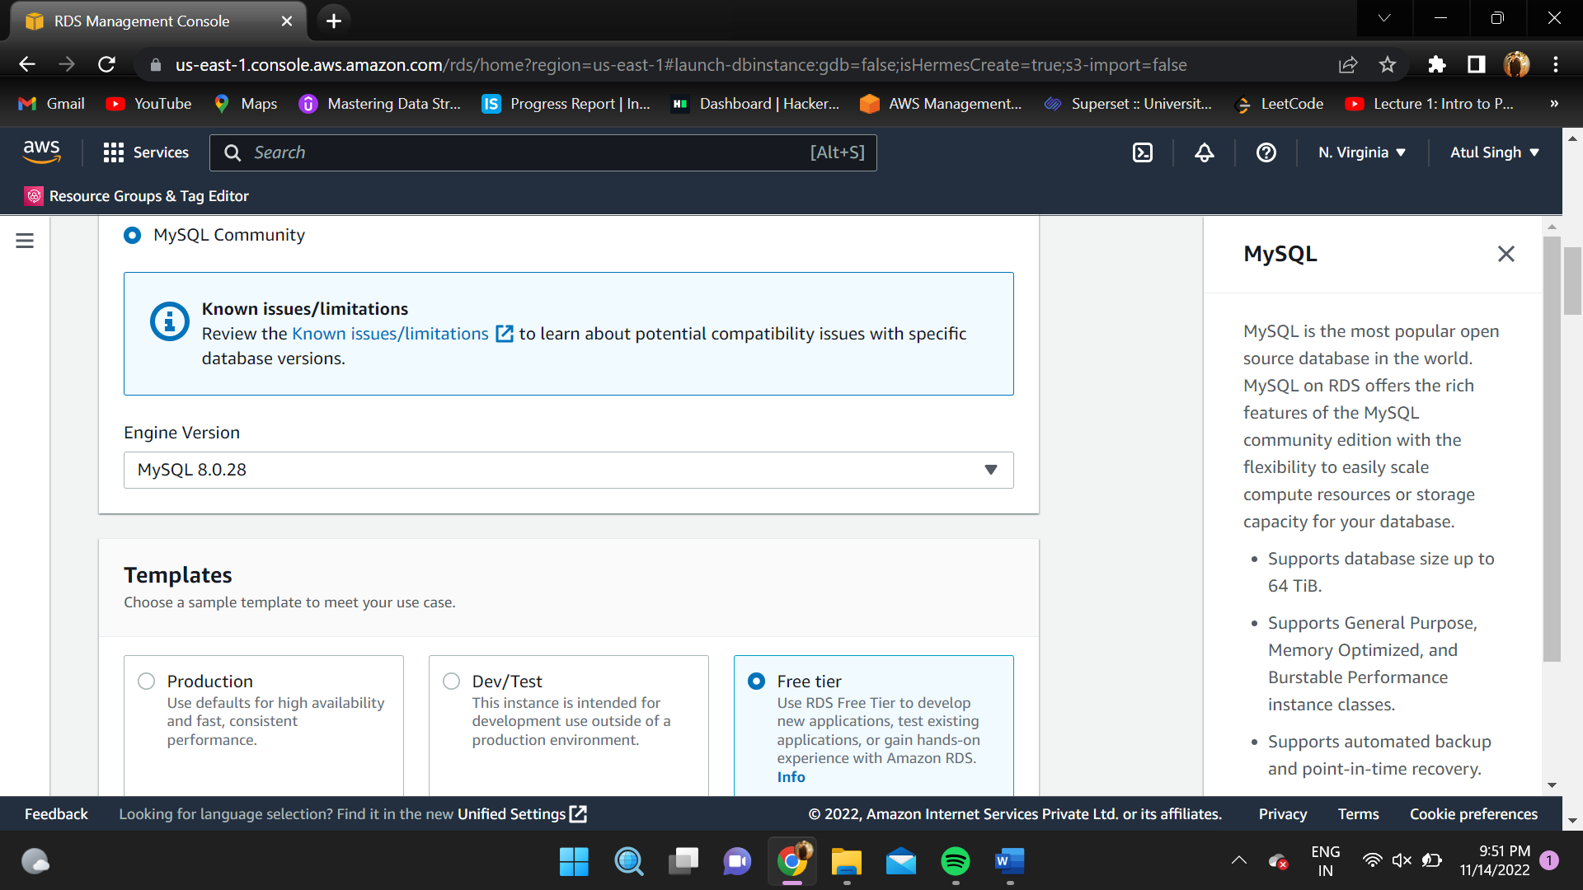

1. Create a Master username and password and remember that for future use.

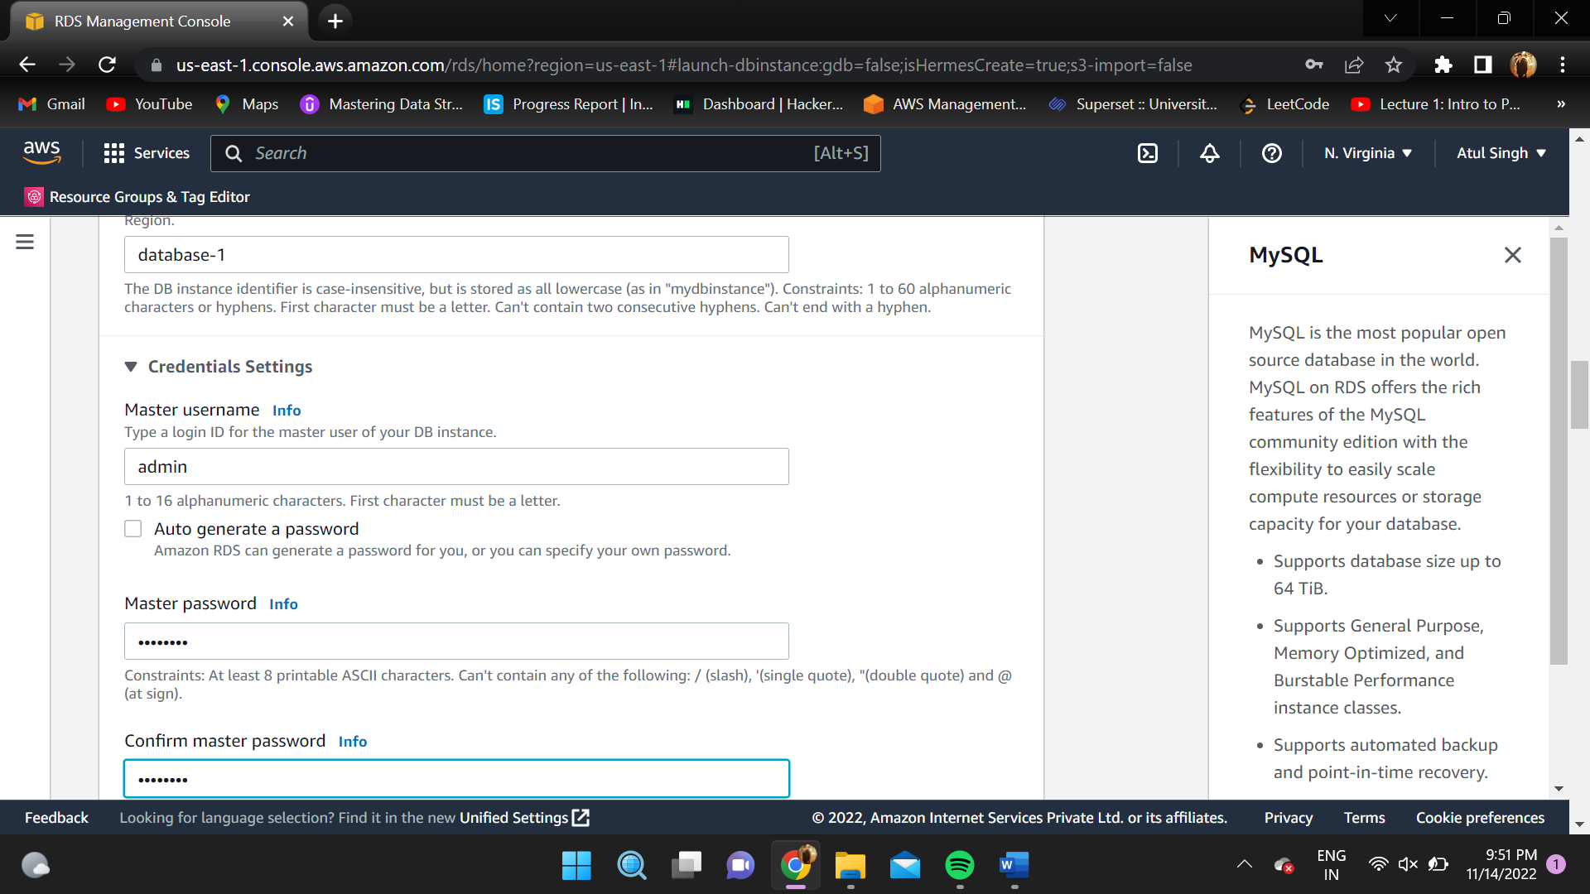

1. Select on create database and wait for the RDS database to be created.

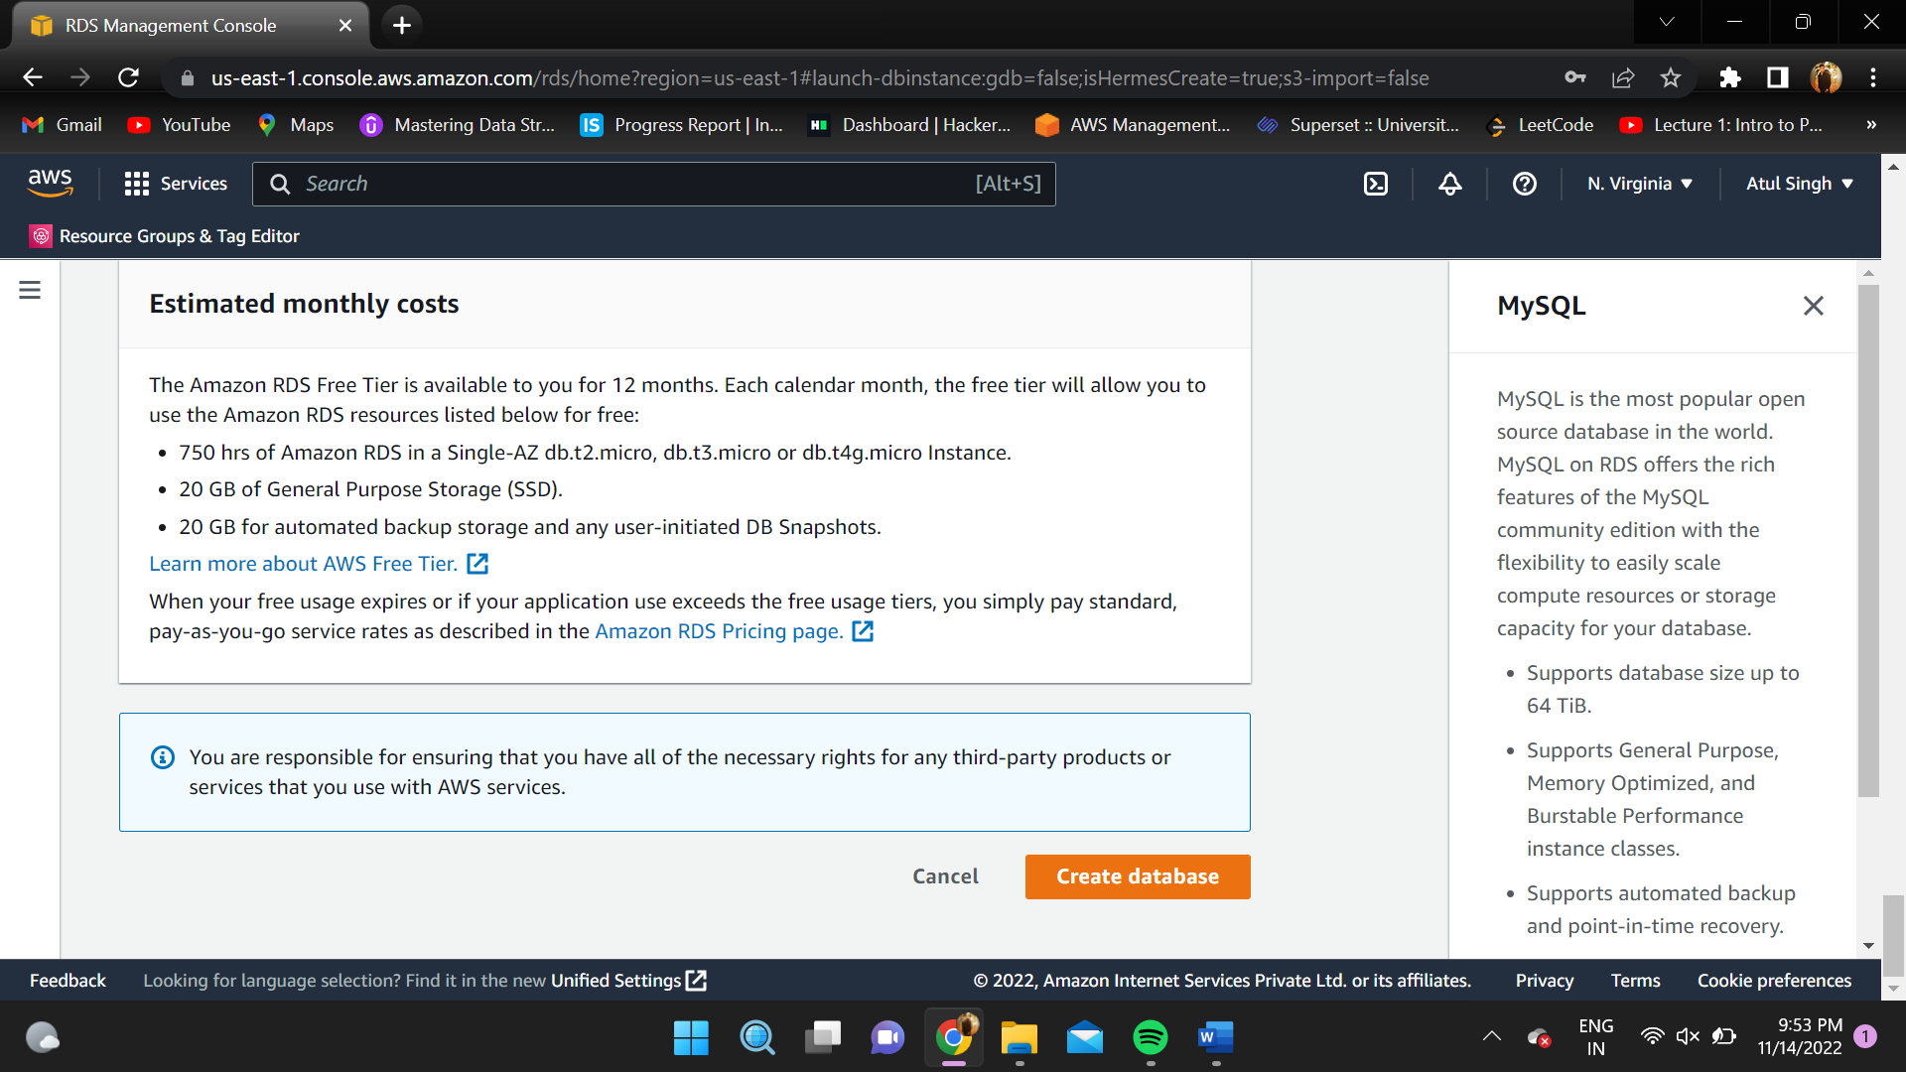

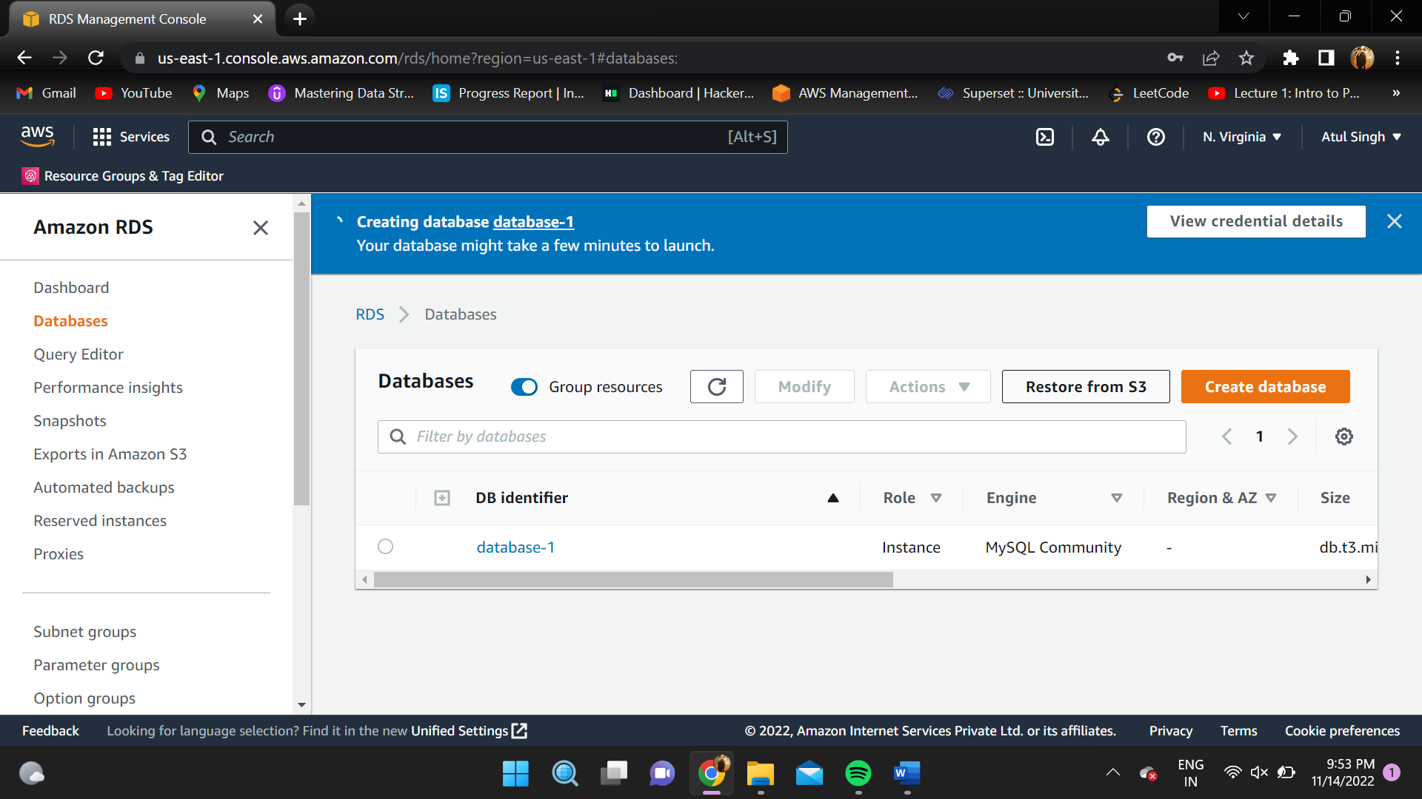

1. Go to AWS DMS console page and click on “Create Replication Instance”.

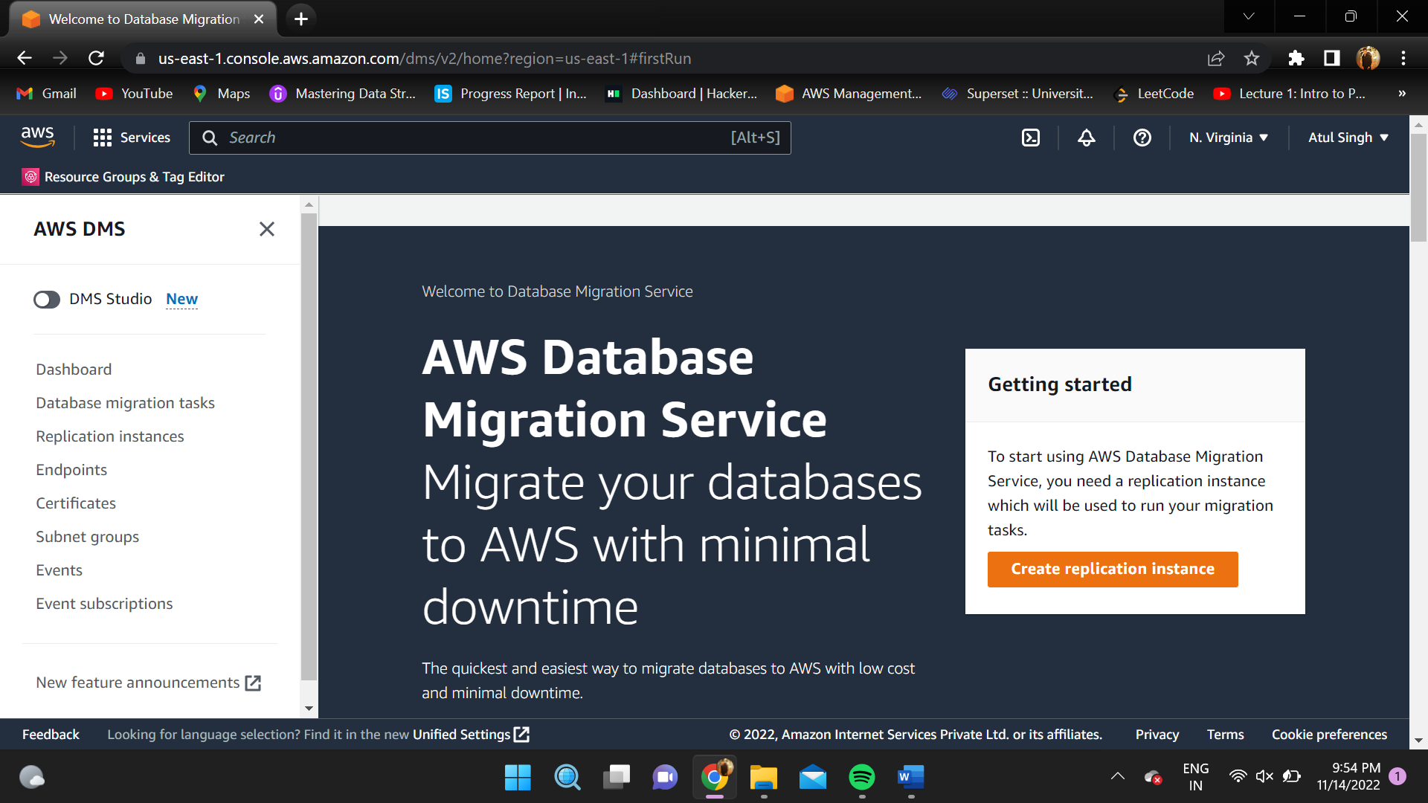

1. Choose the name for your instance and select “t3.micro” in instance class.

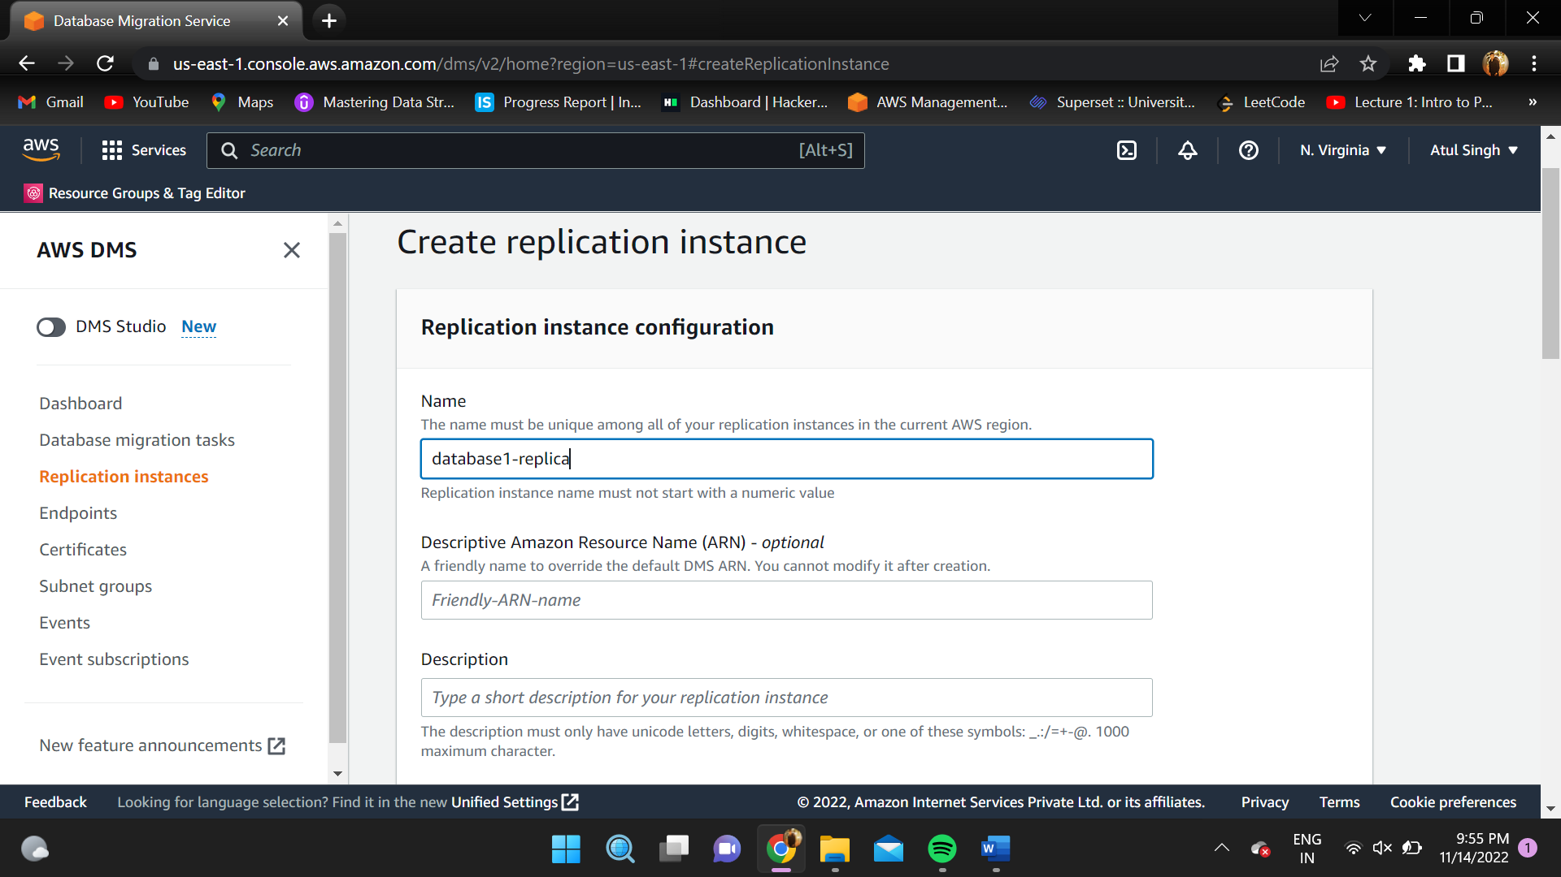

1. Select the vpc you want your instance to be in and select “Dev or test workload”.

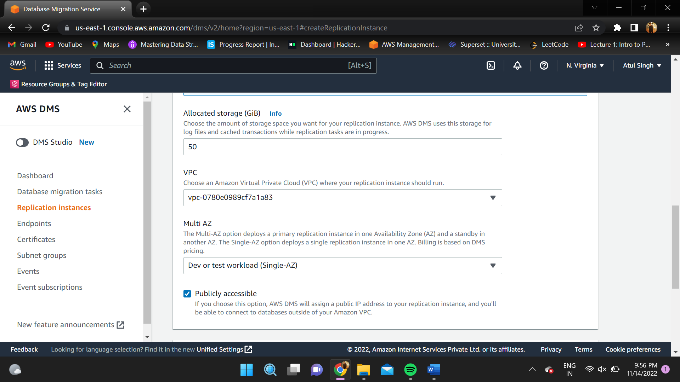

1. Select security group you want your instance to be part of and better to choose “default”.

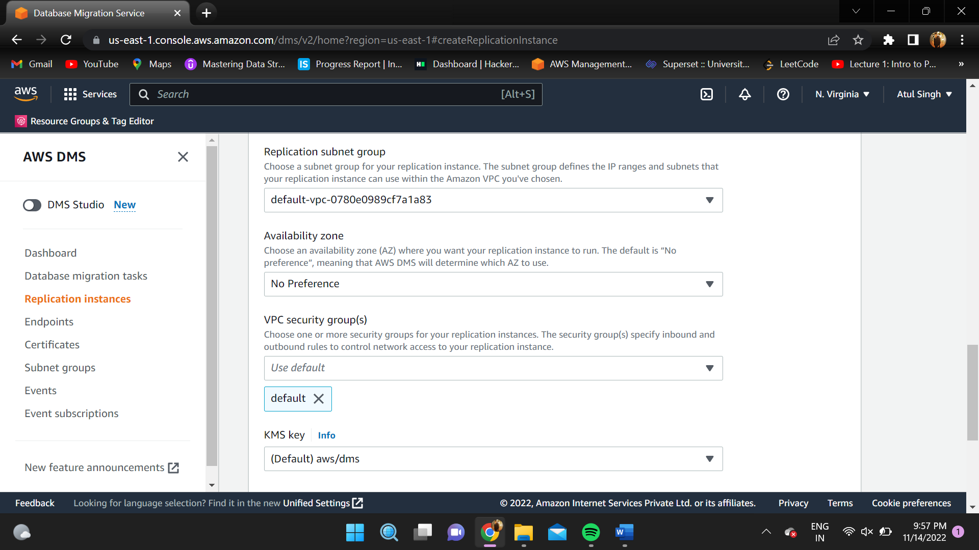

1. Leave other configurations as it is and click on “Create”.

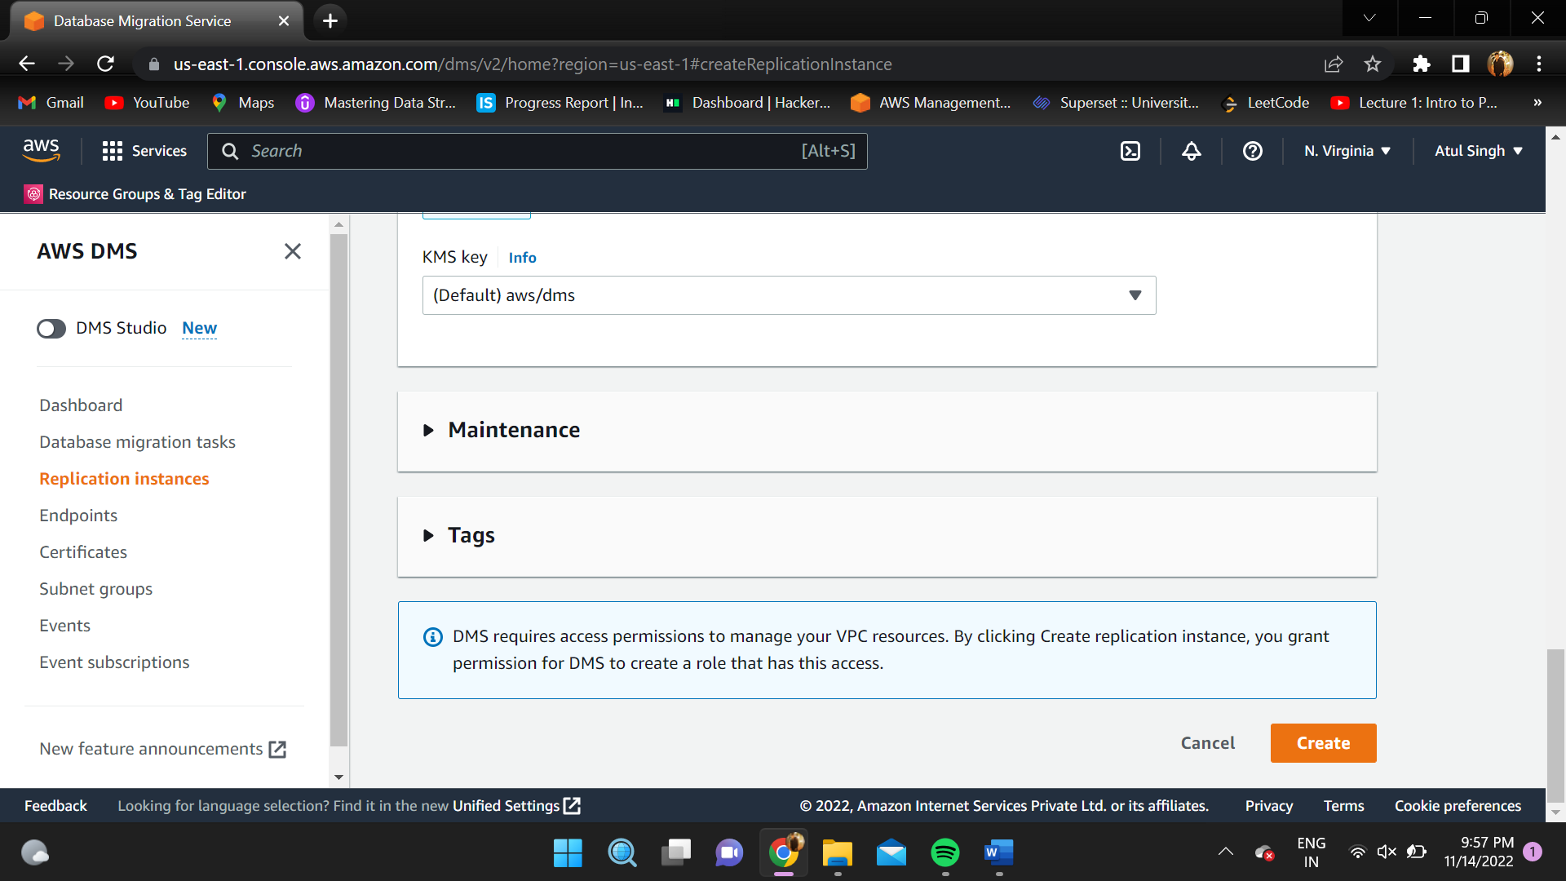

1. Go to “Security Groups” in EC2 console.

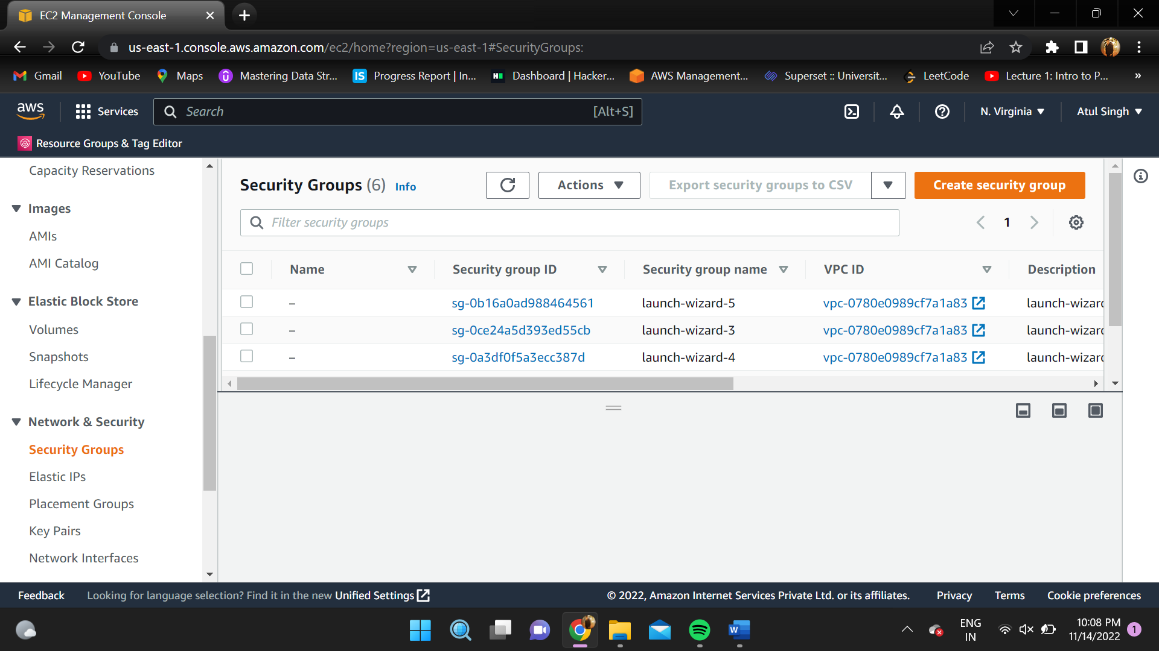

1. Click on your security group name and click on “edit inbound rules”.

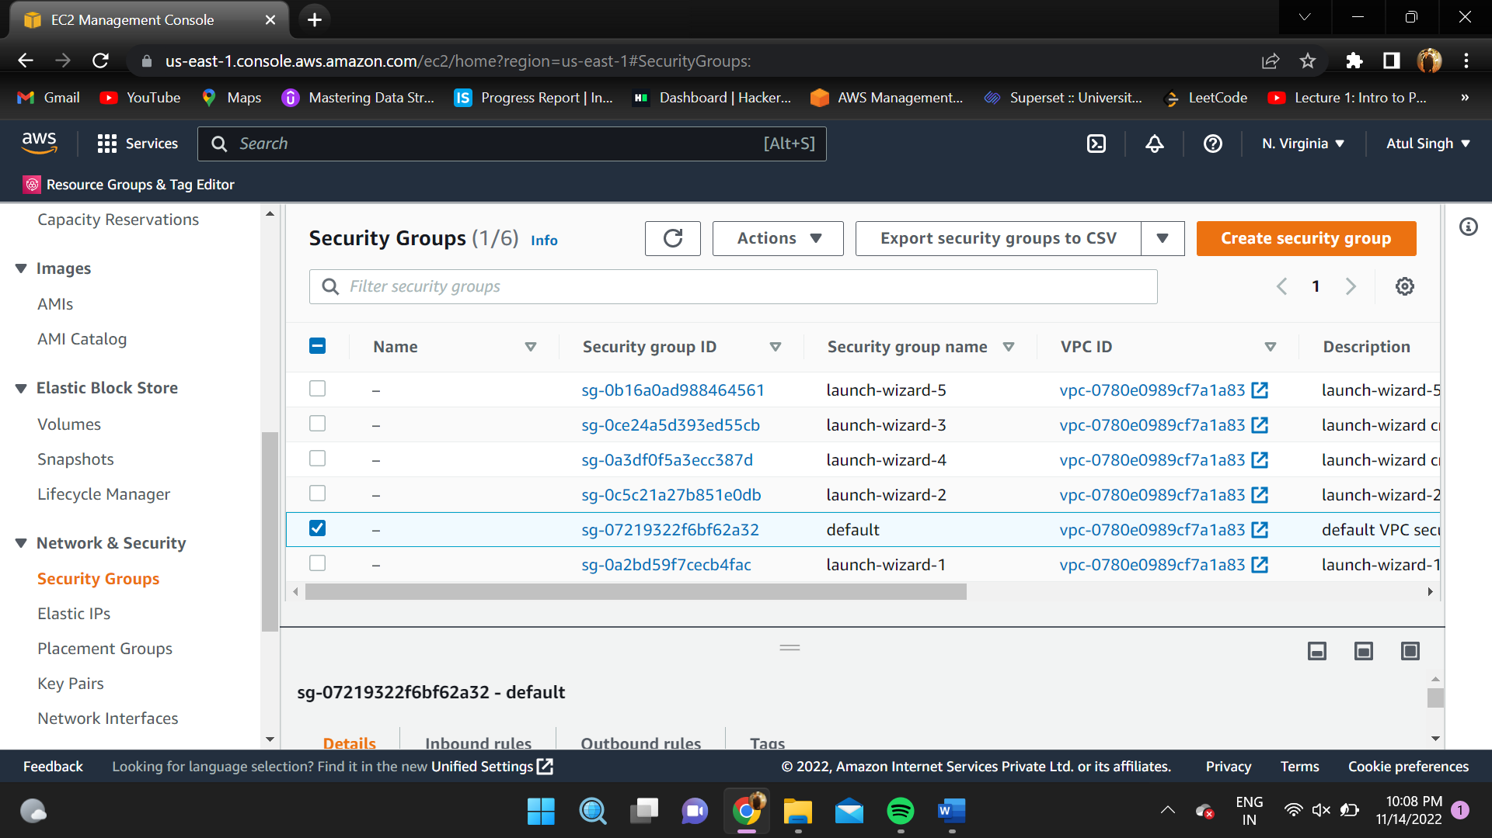

1. Select “MYSQL/Aurora” in type and select the security group of your instance, in this case default and click on “save rules”.

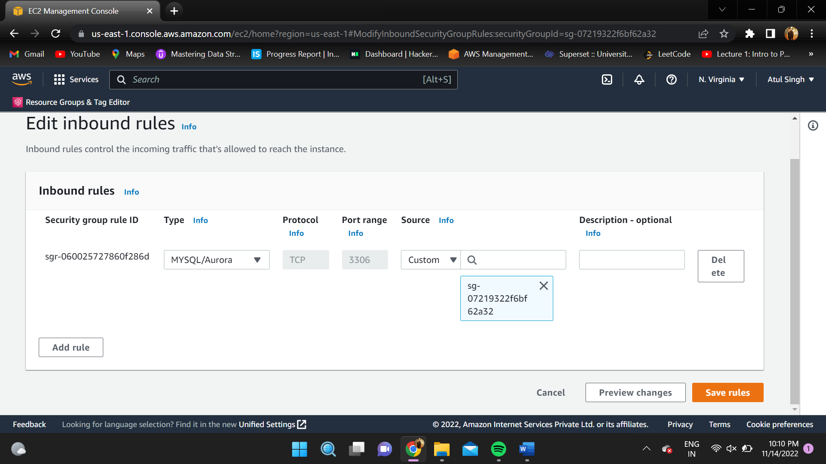

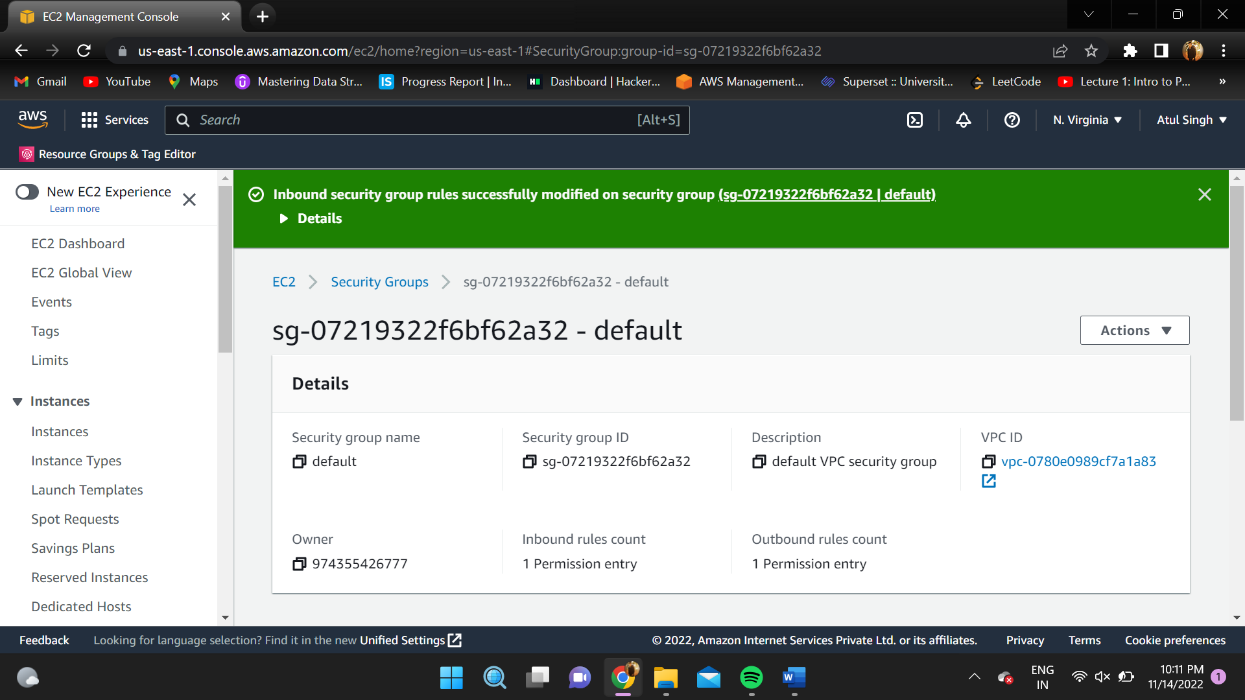

1. Go to AWS DMS console and to the endpoints page and click on “Create Endpoint”.

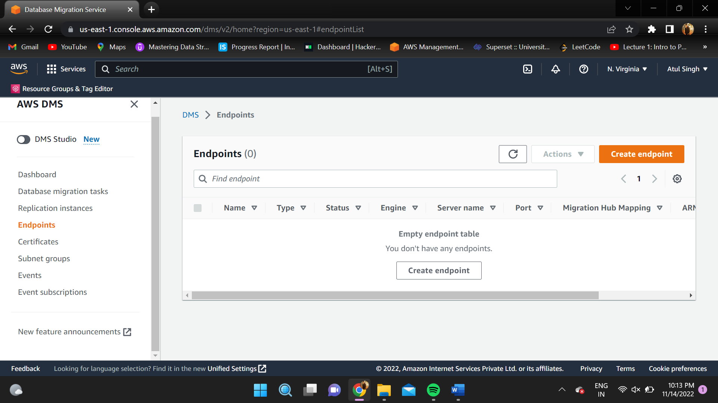

1. Select “Target endpoint” and check the select RDS DB instance box.

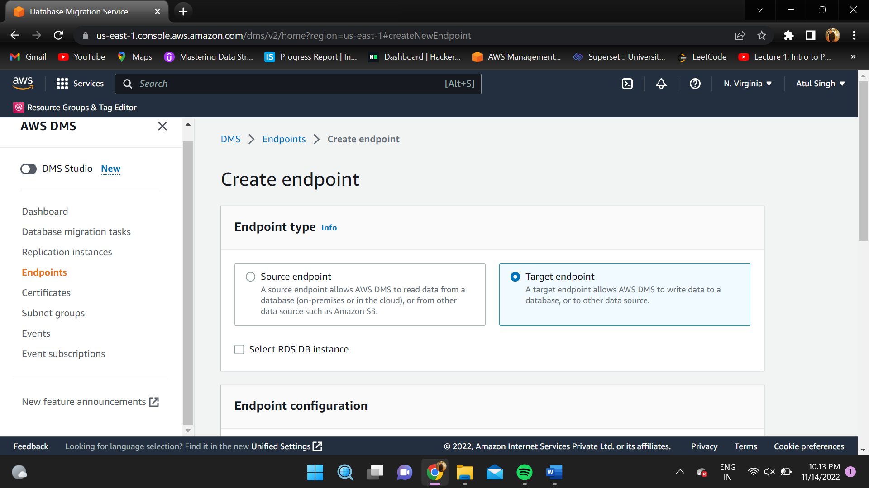

1. Select “Provide access information manually” and enter password chosen before.

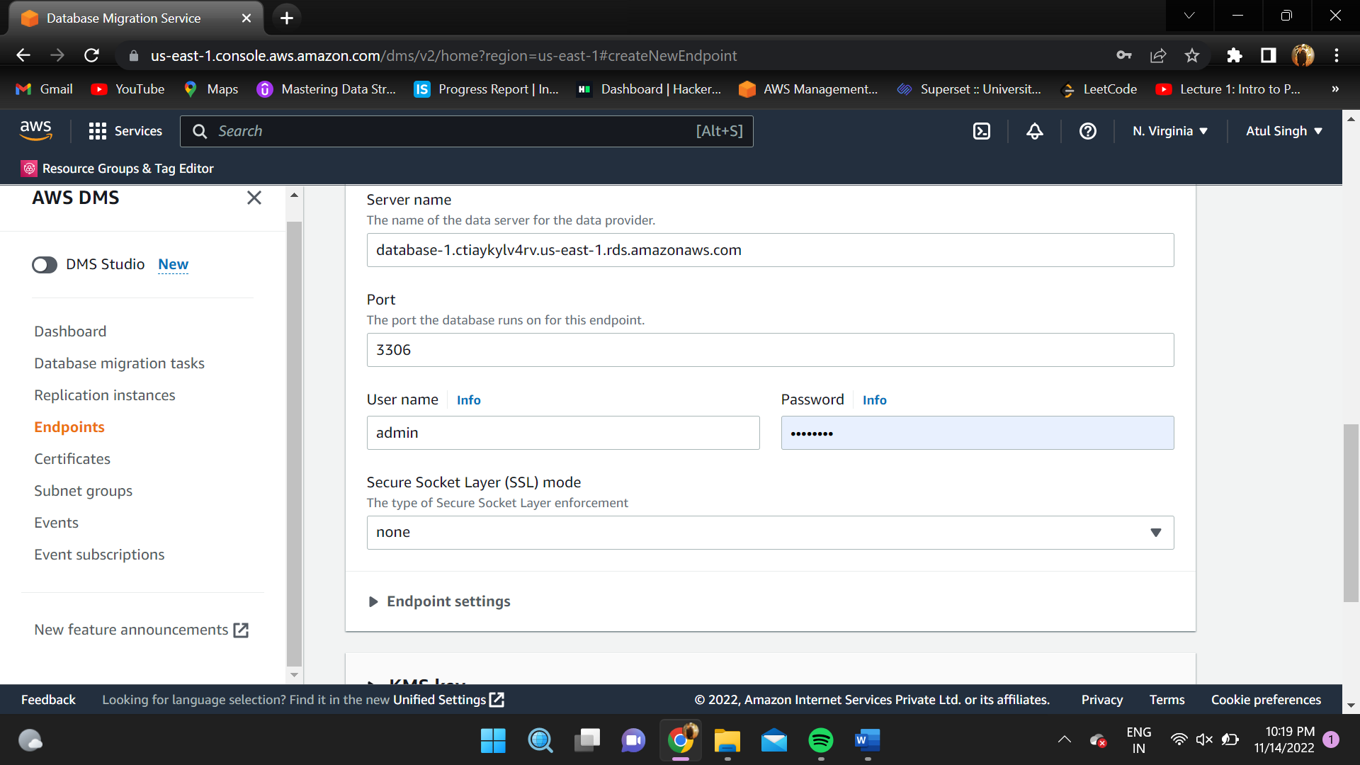

1. Leave other configurations as it is and click on “create endpoint”.

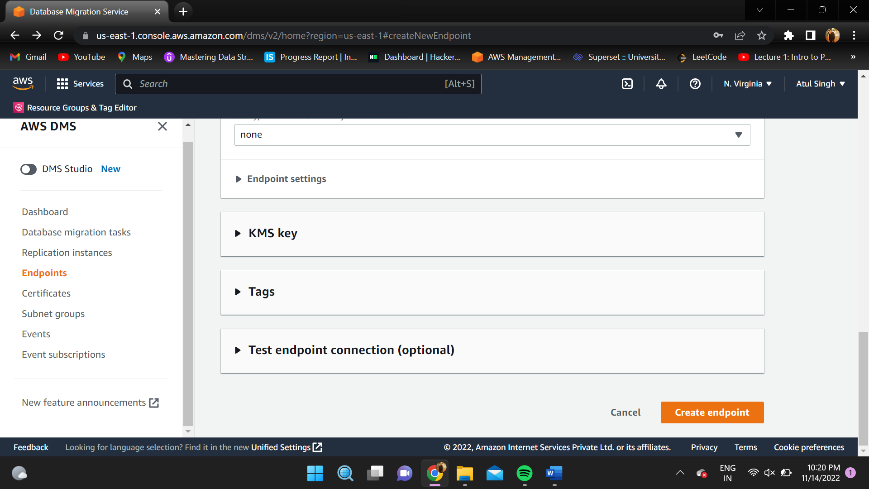

1. Repeat the above steps for “Source Endpoint” except do not check the “select RDS DB instance” and choose a different name for endpoint identifier.

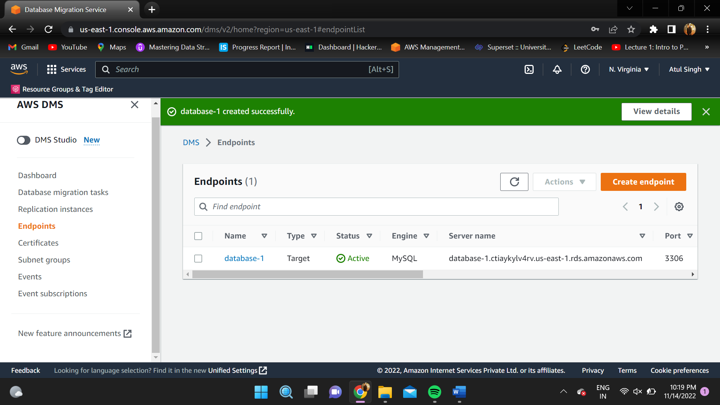

1. Go to “Database migration tasks” page in AWS DMS console and select “Create task”.

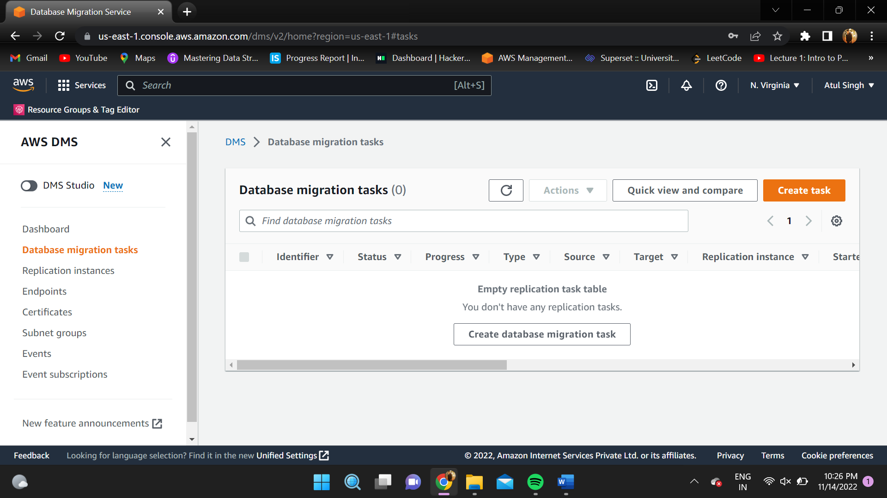

1. Give a name to the task and select replication instance.

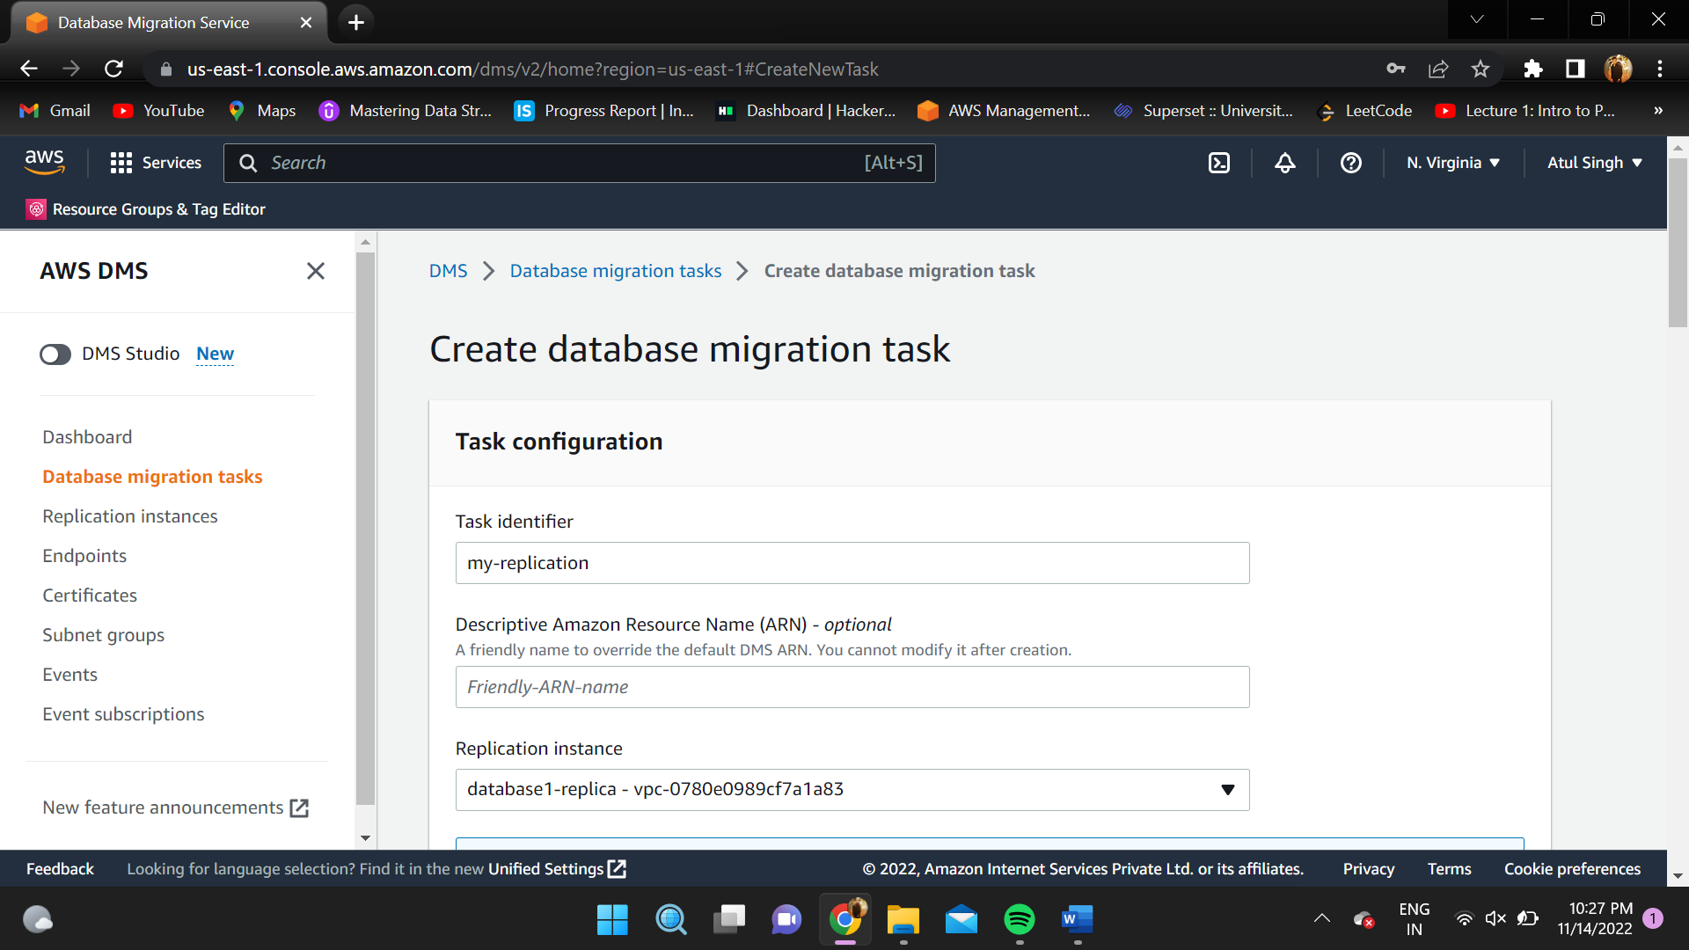

1. Select source and target database endpoints. Also select “migrate existing data” as migration type.

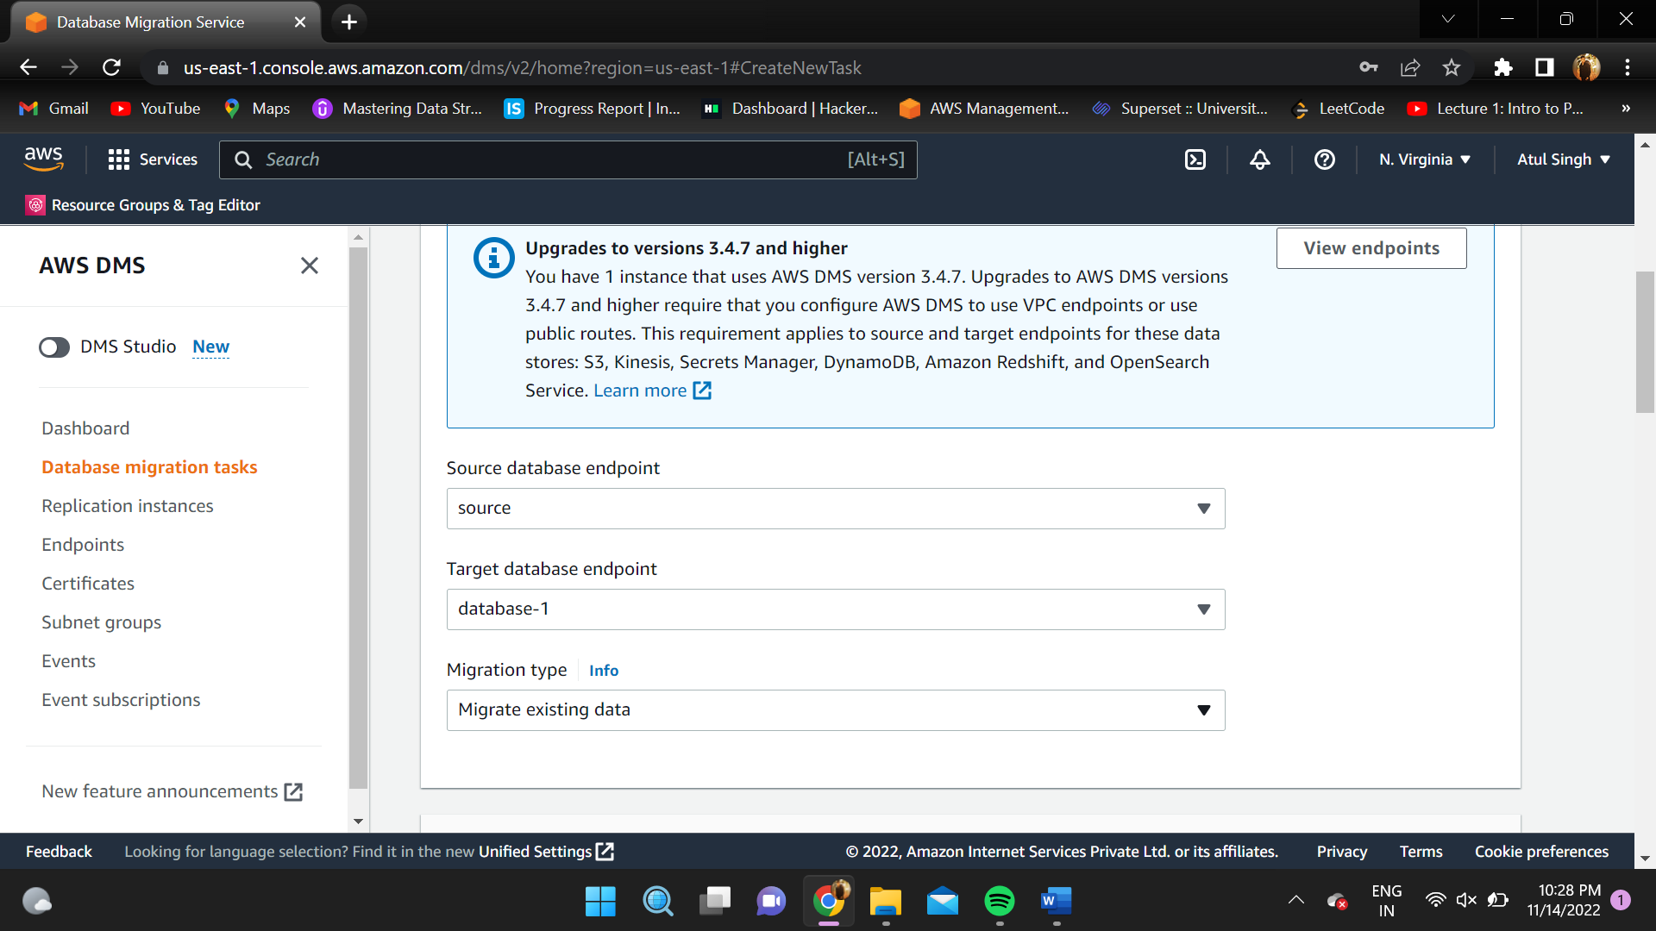

1. Click on “Add new selection rule”, enter a source name- it can be anything and put “%” in table name. Finally click on “create task”.

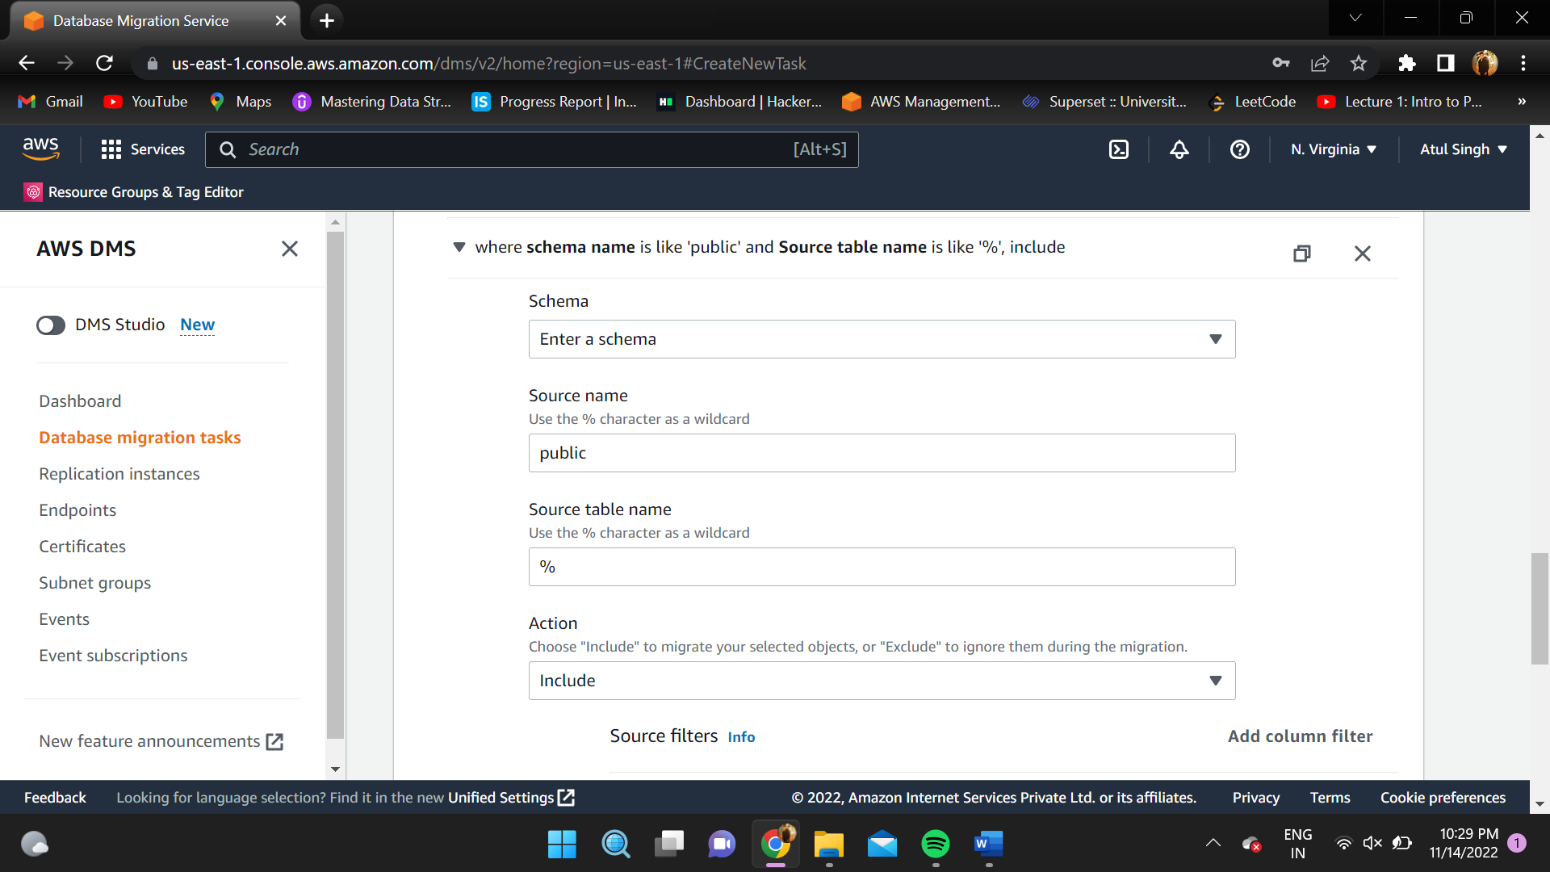

**RESULT:**

A MySQL database was migrated to Amazon RDS with the help of AWS DMS.

